Game Design Document
Fill up the Following document

- Write the title of your project.
Ans - SPEEDO

- What is the goal of the game?
Ans- We should be careful while driving.

- Write a brief story of your game?

Ans- A person was driving the car and then the driver was suddenly fainted and now we have to take the control of the car and save the driver from the coming car on the road.

- Which are the playing characters of this game?
- Playing characters are the ones which respond to the user based on the input from the user
- Cars, monkeys, dinos, wizards etc, are the playing characters in the game.
Number | Character Name | What can this character do?
1 | Player car | This car can move right to left.
2
3
4
5
6
7
8

- Which are the Non Playing Characters of this game?
- Non Playing characters are the ones which don't have an action or a behavior when the user interacts with the game.
- Hurdles, stones, bananas, coins, etc are non playing characters in the game.
Number | Character Name | What can this character do?
1 | Car1 | This car is an obstacle for the player car. It can do the accident of the player car.
2 | Car 2 | This car is an obstacle for the player car. It can do the accident of the player car.
3 | Car3 | This car is an obstacle for the player car. It can do the accident of the player car.
4 | Car4 | This car is an obstacle for the player car. It can do the accident of the player car.
5 | Road | Road plays no role in the game and its is only moving.
6
7
8

Draw your imagination of this game. What does this game look like?
- Draw the game either on your computer or on paper,
- Add images of scenes of the game to show each of the playing and non-playing characters at least once.

Starting scene.
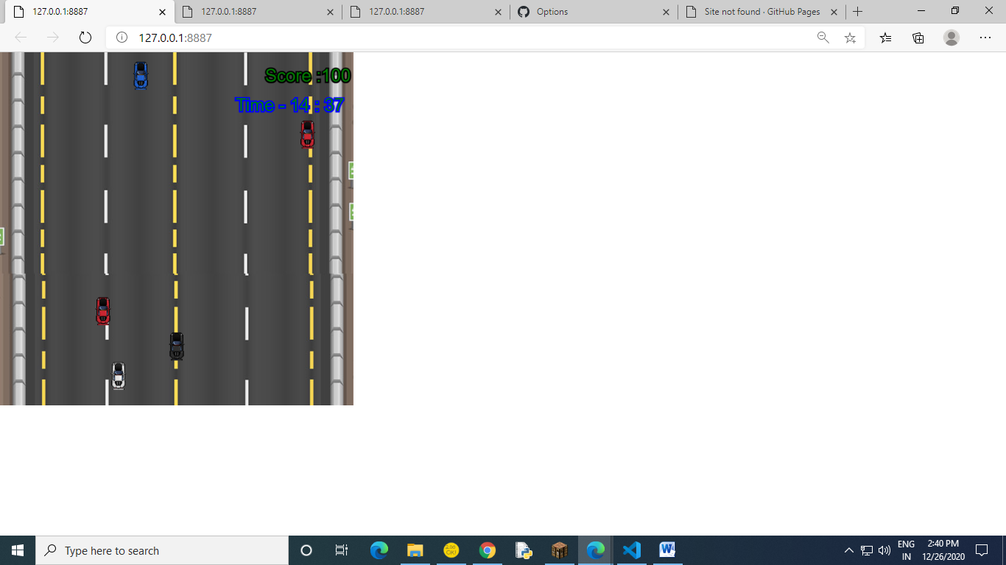

Game over scene
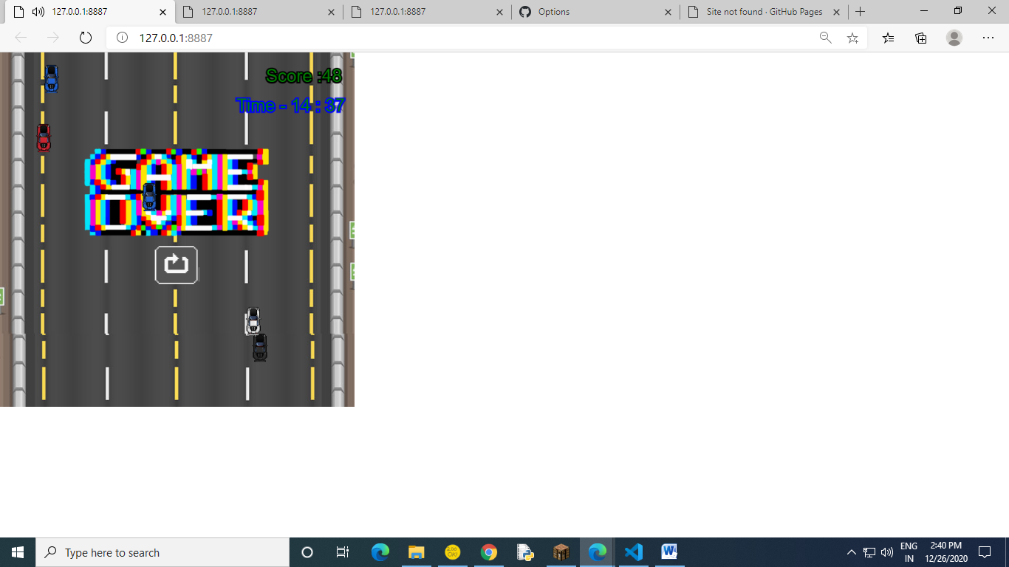

How do you plan to make your game engaging?
And- If the player (the one who is playing the game) has not done the accident of the car then the game is never going to end.

